1. Create Database
Command: create database saledb;
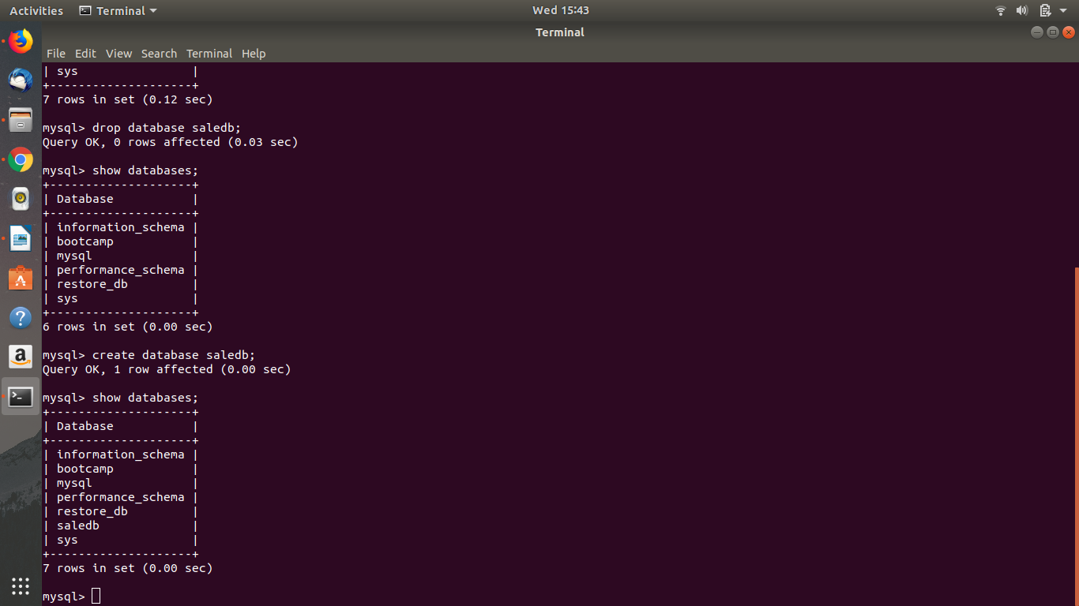

3. Create table:
Command: create table CustomerId

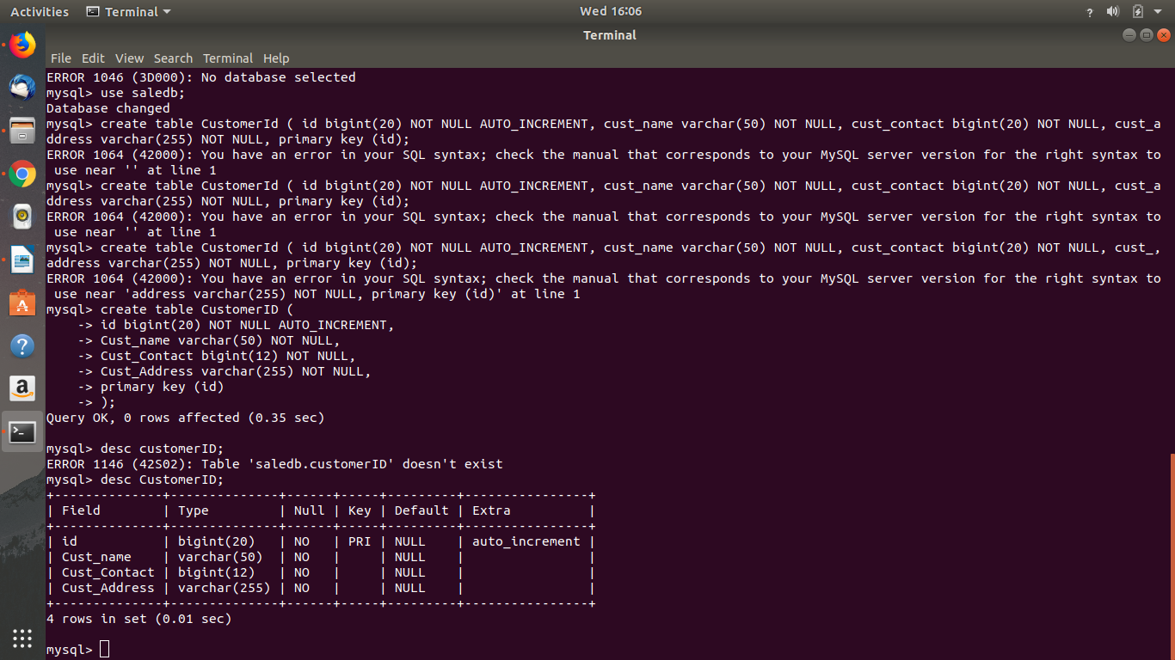

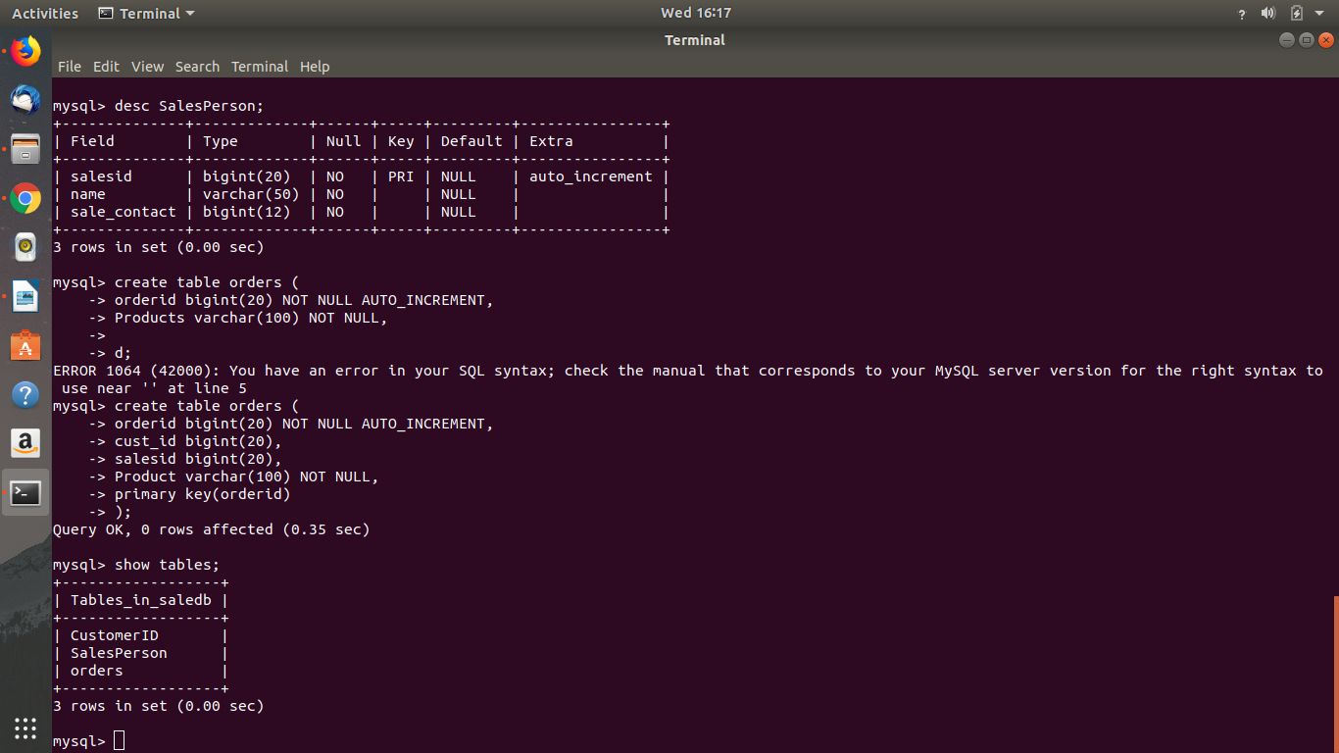
4. Insert Smaple Data:
Command: INSERT INTO CustomerID (Cust_name, Cust_Contact, Cust_Address) values ("Deepanjan Ghosh", 7979797979," flat no 112"), ("Shivam", 6574674567, "hill road 2"), ("Anurag Tiwari", 9887456754, "mount high"), ("Priya kumari", 9897787987, "banglore high street"), ("Riya Anand", 2345654576, "delhi high");

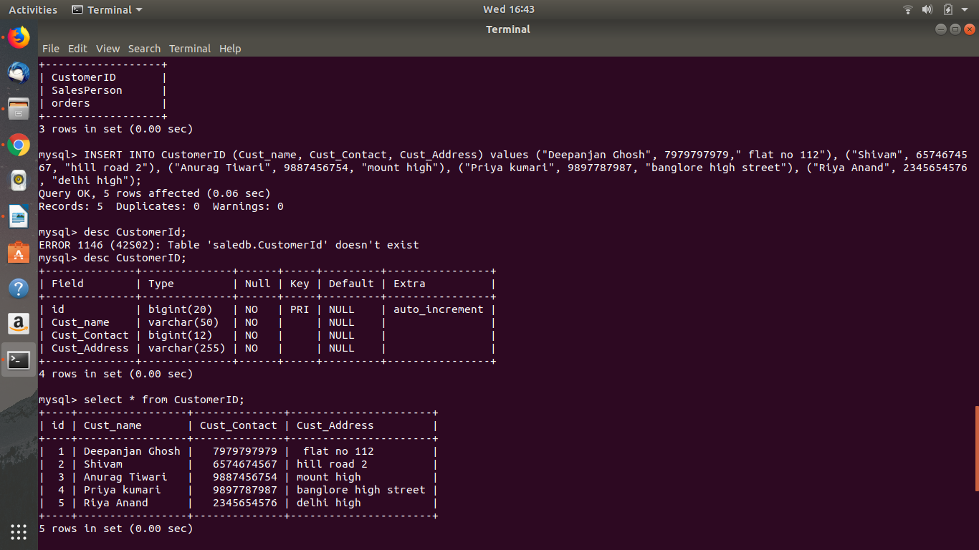

5. Find the sales person have multiple orders
Command: SELECT salesid, COUNT(*) FROM orders GROUP BY salesid HAVING COUNT(*) > 1;
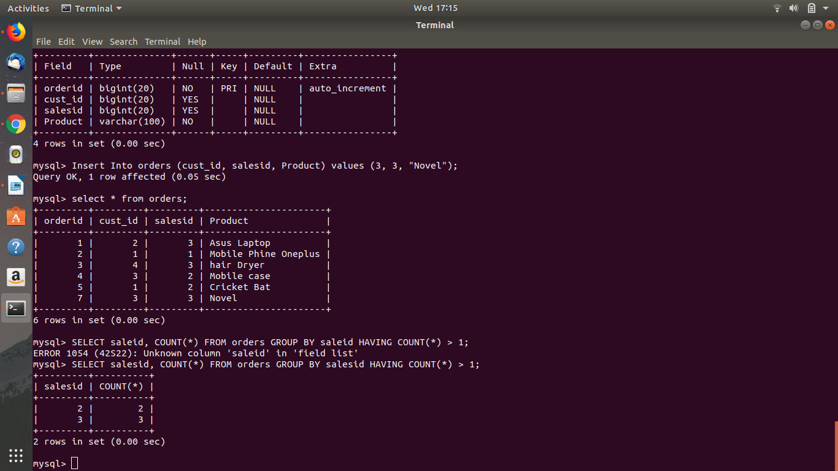

6.Find the all sales person details along with order details
Command: select orders.orderid, orders.cust_id, orders.salesid, orders.Product, SalesPerson.salesid, SalesPerson.name, SalesPerson.sale_contact from SalesPerson inner join orders on orders.orderid = SalesPerson.salesid;
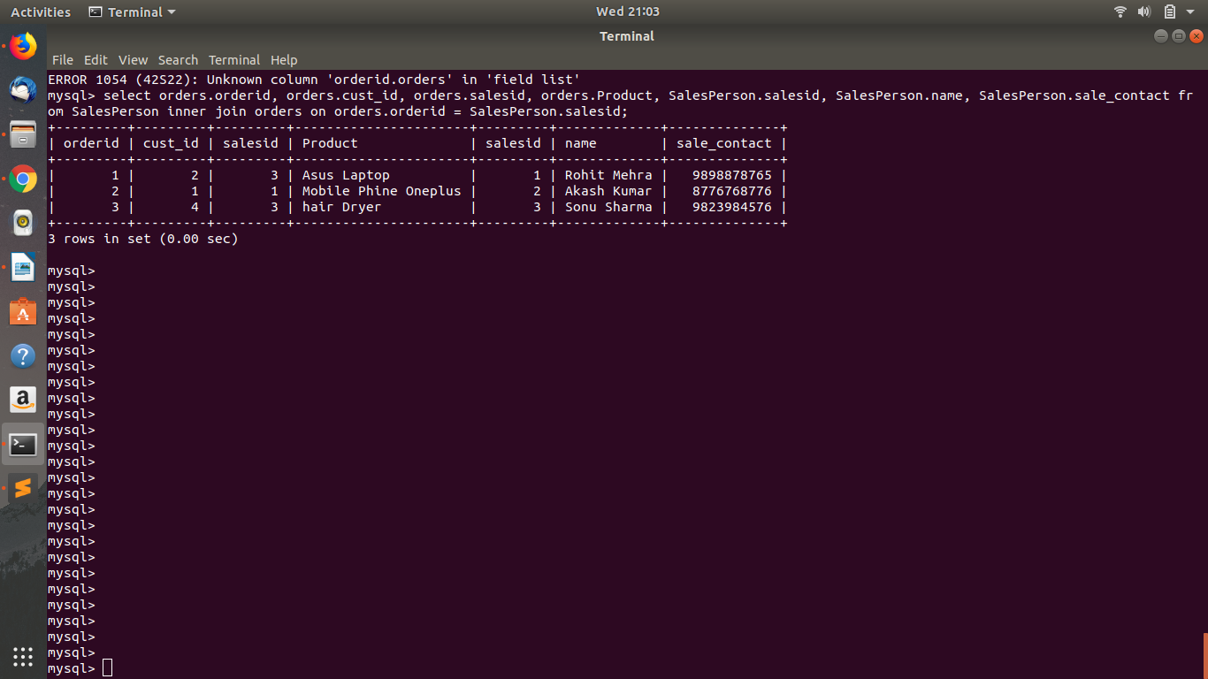

7. Create index
Command: Create Index CustomerIndex on CustomerID(Cust_name);
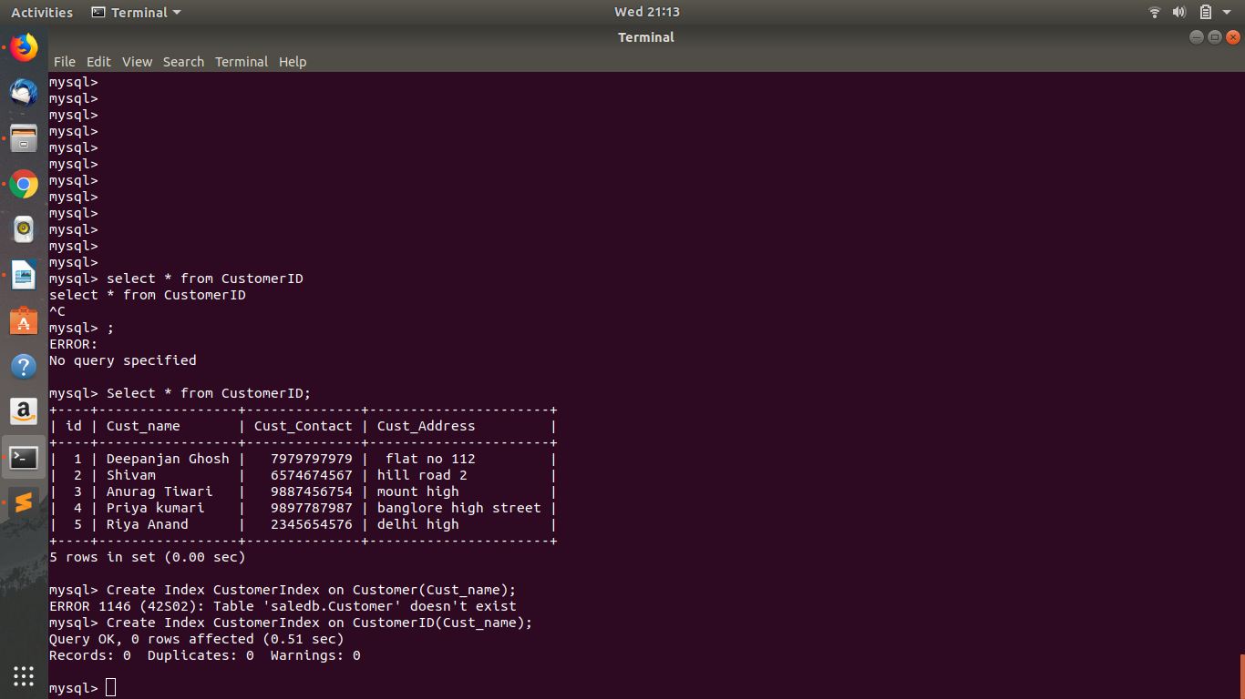

8. How to show index on a table
Command: show index from CustomerID;
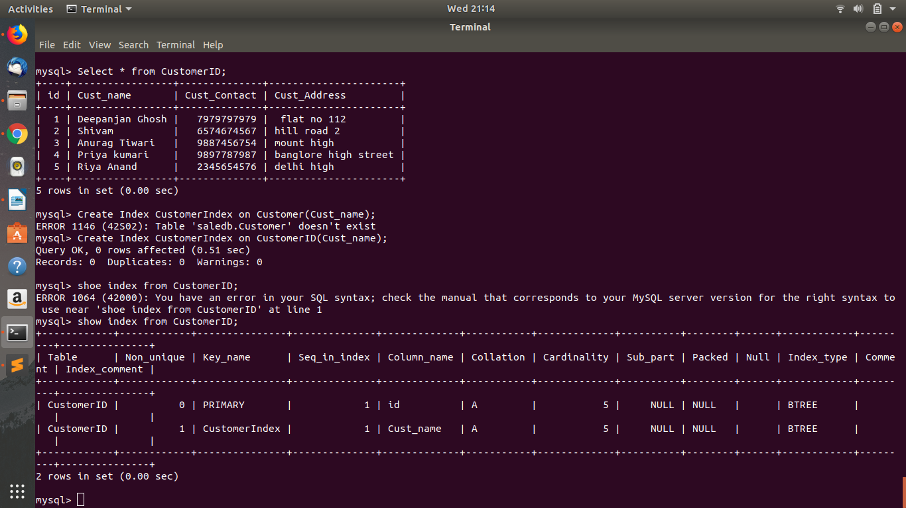

9. Find the order number, sale person name, along with the customer to whom that order belongs to
Command: SELECT orders.orderid, SalesPerson.name, CustomerID.Cust_name FROM ((orders INNER JOIN CustomerID ON orders.orderid = CustomerID.id) INNER JOIN SalesPerson ON orders.orderid = SalesPerson.salesid);
